Deep-Dive Analysis & Interactive Dashboarding

Section 1: Dataset Overview
Before writing any code or building any dashboard, understand your dataset thoroughly. The FMCG_Cleaned_Data.xlsx file contains invoice-level sales records from Andhra Pradesh, India for the full year 2025.

1.1 Key Columns Reference
Column Name | Data Type | Description
invoice_no | String | Unique identifier for each invoice / transaction
invoice_date | Date | Transaction date — use for time-series & monthly trend analysis
customer_code | String | Unique customer ID — use for customer-level aggregations
category | String | 19 FMCG product categories (AGARBATTI, BISCUIT, NOODLES, etc.)
salesman | String | 22 territory salespeople — use for performance comparison
payment_mode | String | Cash or Credit — important for risk and collection analysis
gross_amount | Float | Revenue before discounts — gross sales figure
discount_amt | Float | Discount given per line item
total_amount | Float | Net revenue after discount and taxes — PRIMARY KPI column
market_name | String | Sub-territory / town name under the salesman's beat

1.2 Environment Setup
Install all required Python libraries before starting analysis:
pip install pandas openpyxl matplotlib seaborn scikit-learn plotly jupyter
pip install xlsxwriter # For exporting styled Excel reports

Recommended folder structure for your project:
FMCG_Analysis/
├── data/
│ └── FMCG_Cleaned_Data.xlsx
├── notebooks/
│ ├── 01_KPI_Definitions.ipynb
│ ├── 02_Segmentation_Analysis.ipynb
│ └── 03_Deep_Dive_Report.ipynb
├── outputs/
│ ├── kpi_summary.xlsx
│ └── figures/
└── README.md

Section 2: Define Core KPIs
Based on the FMCG dataset structure, the following 6 KPIs are selected. Each is directly computable from the available columns.

KPI Name | Formula / Measure | Business Rationale | Data Column(s)
Total Revenue | SUM(total_amount) | Measures overall business turnover across all invoices | total_amount
Avg Order Value (AOV) | SUM(total_amount) / COUNT(invoice_no) | Tracks average spend per invoice; FMCG benchmark: ₹800–₹1,200 | total_amount, invoice_no
Discount Rate % | SUM(discount_amt) / SUM(gross_amount) × 100 | Measures pricing pressure and margin risk | discount_amt, gross_amount
Revenue by Category | SUM(total_amount) GROUP BY category | Identifies top-performing product lines (19 categories) | category, total_amount
Credit vs Cash Split | COUNT(payment_mode) / Total × 100 | Monitors payment risk; high credit = collection risk | payment_mode
Salesman Revenue Share | SUM(total_amount) GROUP BY salesman | Evaluates performance of 22 salespeople on territory coverage | salesman, total_amount

2.1 Python Code: Compute All KPIs
Run this notebook cell to compute and print all 6 KPIs in one block:
import pandas as pd

df = pd.read_excel('data/FMCG_Cleaned_Data.xlsx')
df['invoice_date'] = pd.to_datetime(df['invoice_date'])

# KPI 1 — Total Revenue
total_revenue = df['total_amount'].sum()
print(f'Total Revenue: ₹{total_revenue:,.2f}')

# KPI 2 — Average Order Value
aov = df.groupby('invoice_no')['total_amount'].sum().mean()
print(f'Avg Order Value: ₹{aov:,.2f}')

# KPI 3 — Discount Rate %
discount_rate = (df['discount_amt'].sum() / df['gross_amount'].sum()) * 100
print(f'Discount Rate: {discount_rate:.2f}%')

# KPI 4 — Revenue by Category (Top 5)
cat_rev = df.groupby('category')['total_amount'].sum().sort_values(ascending=False)
print(cat_rev.head(5))

# KPI 5 — Payment Mode Split
pay_split = df.groupby('payment_mode')['invoice_no'].nunique()
print(pay_split)

# KPI 6 — Salesman Revenue Share
sales_rev = df.groupby('salesman')['total_amount'].sum().sort_values(ascending=False)
print(sales_rev.head(10))

Section 3: Python Deep-Dive Analysis
This section provides a complete, step-by-step Python implementation for Segmentation Analysis — the recommended deep-dive for this FMCG dataset. Customer segmentation using RFM (Recency, Frequency, Monetary) is ideal because the data has customer_code, invoice_date, and total_amount.

Load & Prepare Data
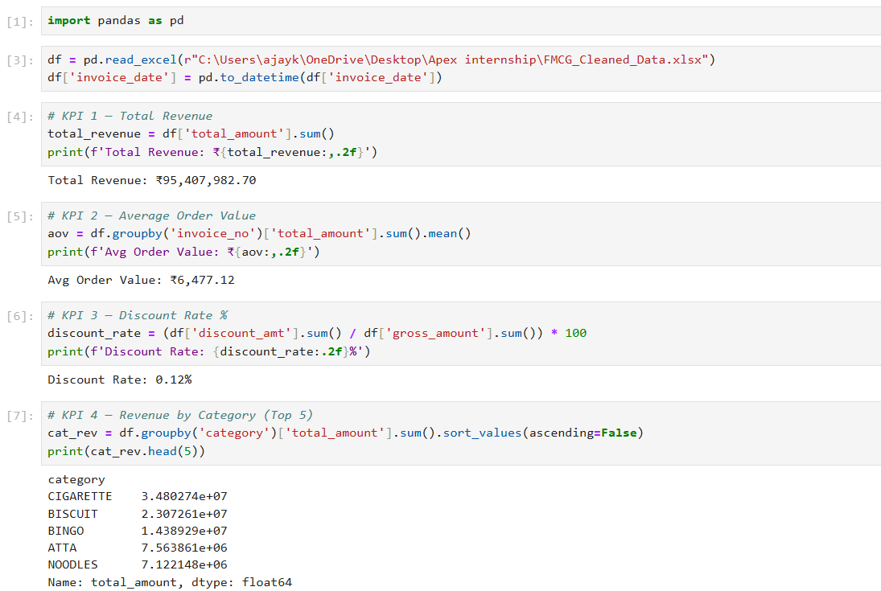

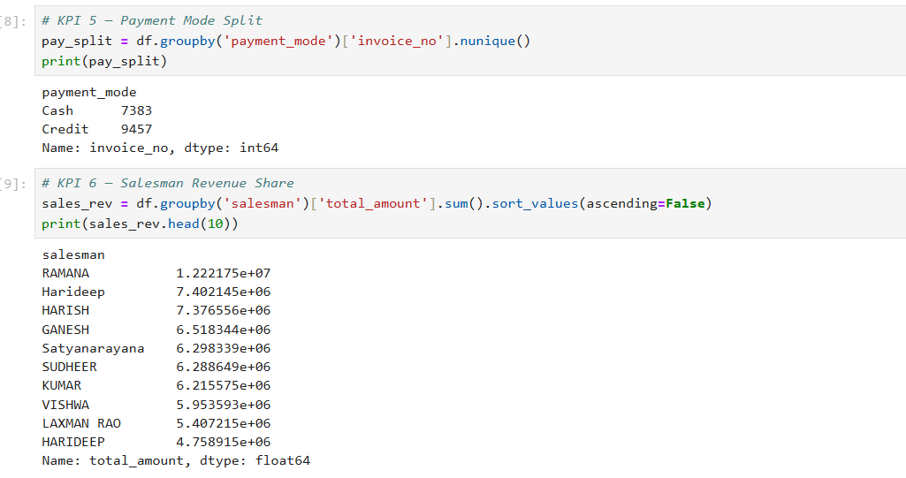
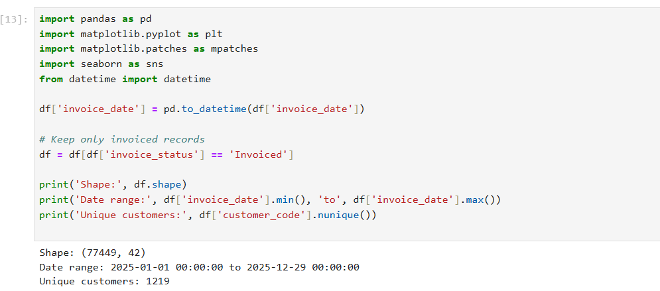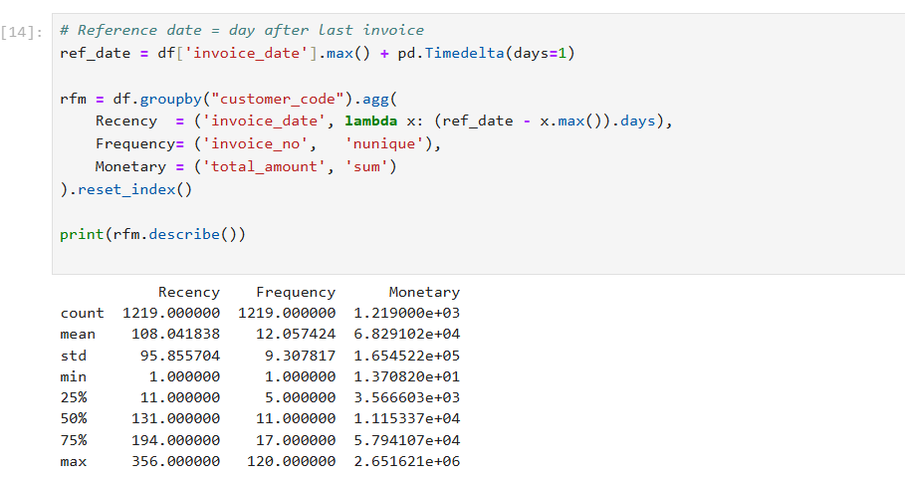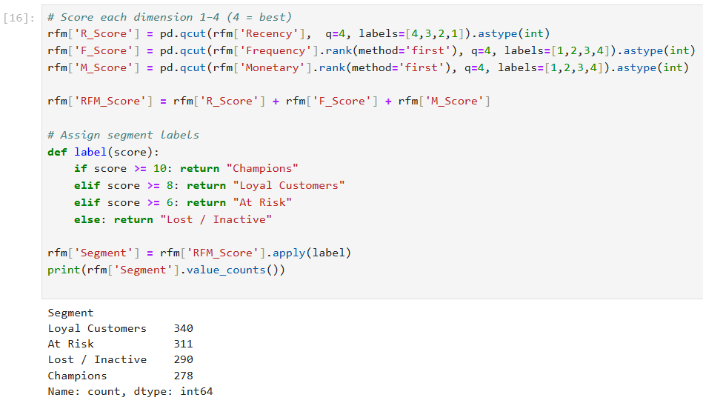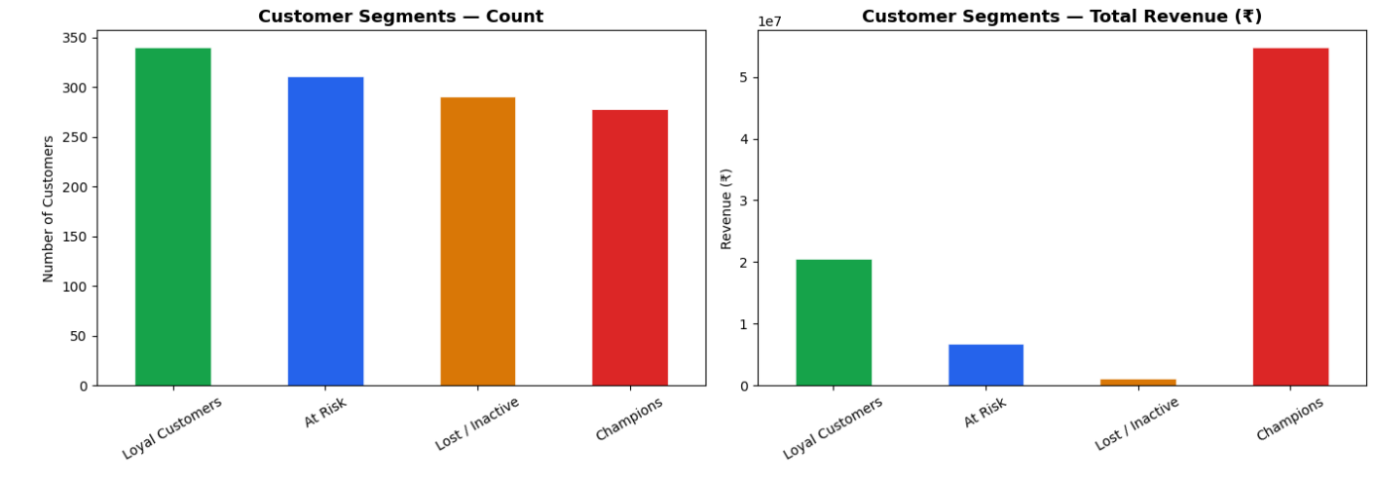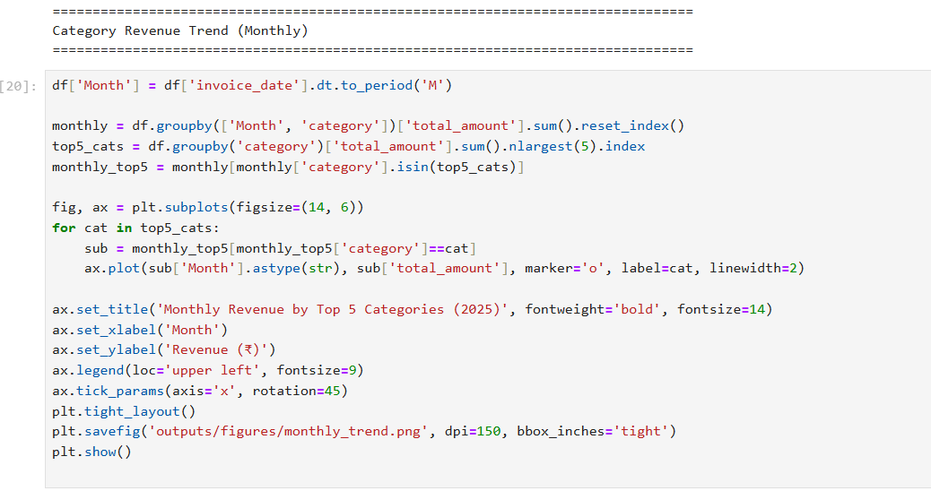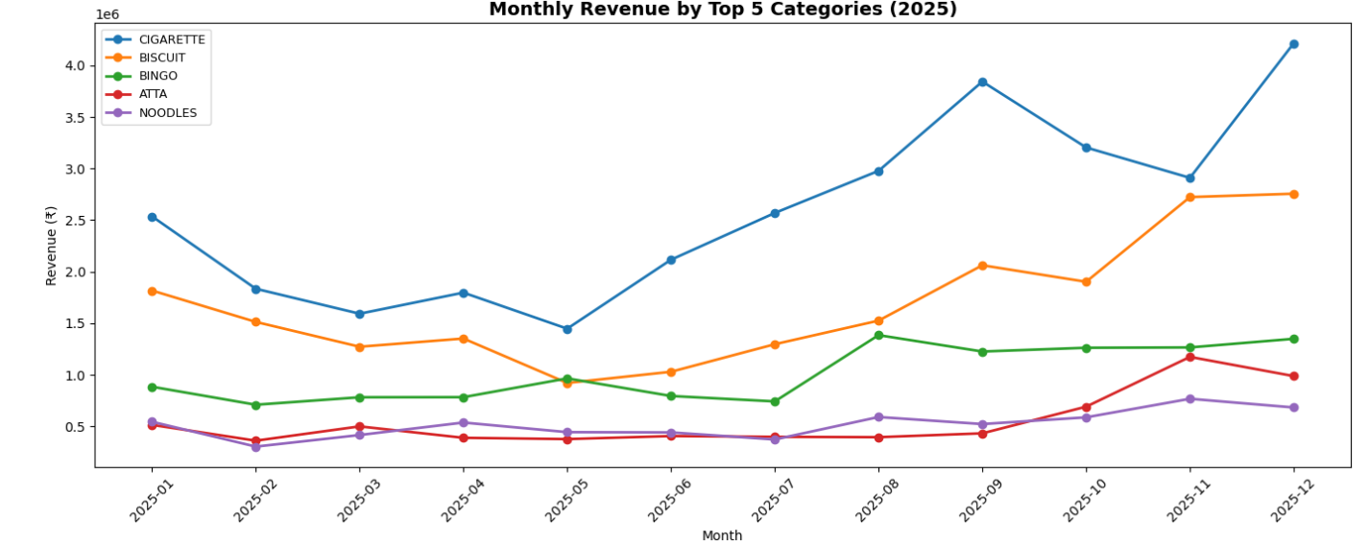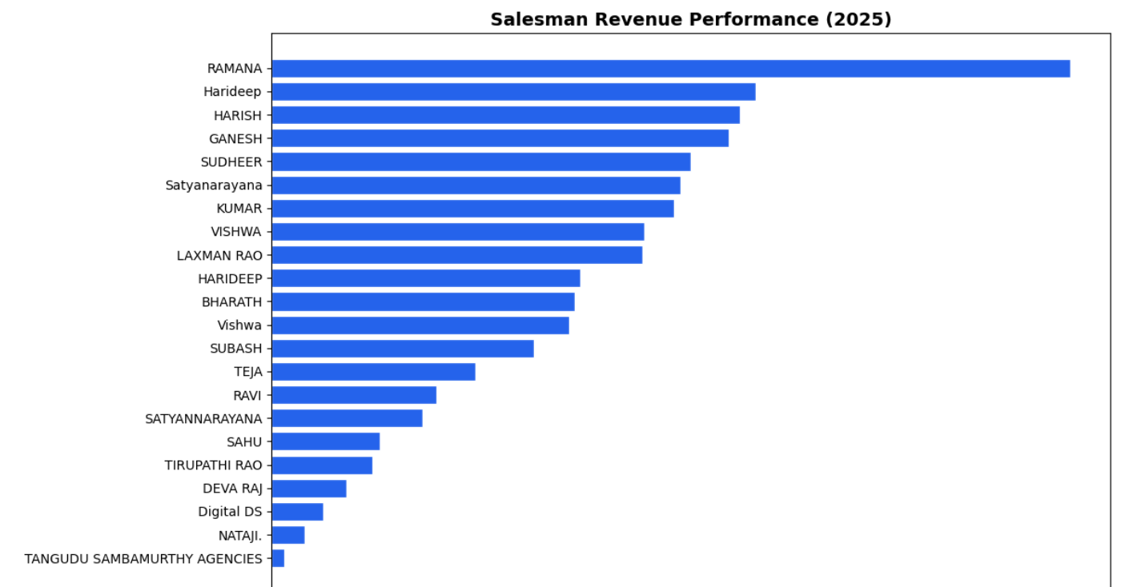

Step 3.2 — Build RFM Table
RFM stands for Recency (how recently a customer bought), Frequency (how often), and Monetary (how much they spent).
# Reference date = day after last invoice
ref_date = df['invoice_date'].max() + pd.Timedelta(days=1)

rfm = df.groupby("customer_code").agg(
Recency = ('invoice_date', lambda x: (ref_date - x.max()).days),
Frequency= ('invoice_no', 'nunique'),
Monetary = ('total_amount', 'sum')
).reset_index()

print(rfm.describe())

Step 3.3 — Score & Assign Segments
# Score each dimension 1–4 (4 = best)
rfm['R_Score'] = pd.qcut(rfm['Recency'], q=4, labels=[4,3,2,1]).astype(int)
rfm['F_Score'] = pd.qcut(rfm['Frequency'].rank(method='first'), q=4, labels=[1,2,3,4]).astype(int)
rfm['M_Score'] = pd.qcut(rfm['Monetary'].rank(method='first'), q=4, labels=[1,2,3,4]).astype(int)

rfm['RFM_Score'] = rfm['R_Score'] + rfm['F_Score'] + rfm['M_Score']

# Assign segment labels
def label(score):
if score >= 10: return "Champions"
elif score >= 8: return "Loyal Customers"
elif score >= 6: return "At Risk"
else: return "Lost / Inactive"

rfm['Segment'] = rfm['RFM_Score'].apply(label)
print(rfm['Segment'].value_counts())

Step 3.4 — Visualize Segments
fig, axes = plt.subplots(1, 2, figsize=(14, 5))

# Chart 1: Segment count bar
seg_count = rfm['Segment'].value_counts()
colors = ['#16A34A','#2563EB','#D97706','#DC2626']
seg_count.plot(kind='bar', ax=axes[0], color=colors, edgecolor='white', linewidth=0.5)
axes[0].set_title('Customer Segments — Count', fontweight='bold', fontsize=13)
axes[0].set_xlabel('')
axes[0].set_ylabel('Number of Customers')
axes[0].tick_params(axis='x', rotation=30)

# Chart 2: Segment monetary value
seg_money = rfm.groupby('Segment')['Monetary'].sum().reindex(seg_count.index)
seg_money.plot(kind='bar', ax=axes[1], color=colors, edgecolor='white', linewidth=0.5)
axes[1].set_title('Customer Segments — Total Revenue (₹)', fontweight='bold', fontsize=13)
axes[1].set_xlabel('')
axes[1].set_ylabel('Revenue (₹)')
axes[1].tick_params(axis='x', rotation=30)

plt.tight_layout()
plt.savefig('outputs/figures/rfm_segments.png', dpi=150, bbox_inches='tight')
plt.show()

Step 3.5 — Category Revenue Trend (Monthly)
Visualize how monthly revenue has evolved over the year across top categories:
df['Month'] = df['invoice_date'].dt.to_period('M')

monthly = df.groupby(['Month', 'category'])['total_amount'].sum().reset_index()
top5_cats = df.groupby('category')['total_amount'].sum().nlargest(5).index
monthly_top5 = monthly[monthly['category'].isin(top5_cats)]

fig, ax = plt.subplots(figsize=(14, 6))
for cat in top5_cats:
sub = monthly_top5[monthly_top5['category']==cat]
ax.plot(sub['Month'].astype(str), sub['total_amount'], marker='o', label=cat, linewidth=2)

ax.set_title('Monthly Revenue by Top 5 Categories (2025)', fontweight='bold', fontsize=14)
ax.set_xlabel('Month')
ax.set_ylabel('Revenue (₹)')
ax.legend(loc='upper left', fontsize=9)
ax.tick_params(axis='x', rotation=45)
plt.tight_layout()
plt.savefig('outputs/figures/monthly_trend.png', dpi=150, bbox_inches='tight')
plt.show()

Step 3.6 — Salesman Performance Analysis
salesman_df = df.groupby('salesman').agg(
Revenue = ('total_amount', 'sum'),
Invoices = ('invoice_no', 'nunique'),
Customers = ('customer_code', 'nunique'),
Avg_Invoice= ('total_amount', 'mean')
).reset_index().sort_values("Revenue", ascending=False)

# Plot horizontal bar chart
fig, ax = plt.subplots(figsize=(12, 7))
ax.barh(salesman_df['salesman'], salesman_df['Revenue']/1e5,
color='#2563EB', edgecolor='white')
ax.set_xlabel('Revenue (₹ Lakhs)')
ax.set_title('Salesman Revenue Performance (2025)', fontweight='bold', fontsize=14)
ax.invert_yaxis()
plt.tight_layout()
plt.savefig('outputs/figures/salesman_perf.png', dpi=150, bbox_inches='tight')
plt.show()

Power BI Dashboard Build
Build a 3-page interactive dashboard in Power BI Desktop. This guide assumes Power BI Desktop is installed (free from Microsoft). The FMCG data loads directly from the cleaned Excel file.

DAX Measures
Create these measures in Power BI (right-click Sheet1 table → New Measure):
// Measure 1: Total Revenue
Total Revenue = SUM(Sheet1[total_amount])

// Measure 2: Average Order Value
AOV = DIVIDE([Total Revenue], DISTINCTCOUNT(Sheet1[invoice_no]))

// Measure 3: Discount Rate %
Discount Rate % = DIVIDE(SUM(Sheet1[discount_amt]), SUM(Sheet1[gross_amount])) * 100

// Measure 4: Total Invoices
Total Invoices = DISTINCTCOUNT(Sheet1[invoice_no])

// Measure 5: Unique Customers
Unique Customers = DISTINCTCOUNT(Sheet1[customer_code])

// Measure 6: Credit Invoice %
Credit % = DIVIDE(CALCULATE(DISTINCTCOUNT(Sheet1[invoice_no]),
Sheet1[payment_mode]="Credit"),
[Total Invoices]) * 100

// Measure 7: MoM Revenue Growth
MoM Growth % =
VAR CurrentMonth = [Total Revenue]
VAR PrevMonth = CALCULATE([Total Revenue],
DATEADD(DateTable[Date], -1, MONTH))
RETURN DIVIDE(CurrentMonth - PrevMonth, PrevMonth) * 100

